Collegiate Wind Competition 2019
Mechanical Design Tunnel Team

Final Proposal

Abdulaziz Alawad
Faisal Alrashidi
Naser Alrashidi
Tanner Lehr
Riley Sinek

2018-2019



Project Sponsor: United States Department of Energy
Faculty Advisor: David Willy
Instructor: Sarah Oman

DISCLAIMER
This report was prepared by students as part of a university course requirement. While considerable effort has been put into the project, it is not the work of licensed engineers and has not undergone the extensive verification that is common in the profession. The information, data, conclusions, and content of this report should not be relied on or utilized without thorough, independent testing and verification. University faculty members may have been associated with this project as advisors, sponsors, or course instructors, but as such they are not responsible for the accuracy of results or conclusions.
Table of Contents
DISCLAIMER i
1 BACKGROUND 1
1.1 Introduction 1
1.2 Project Description 1
2 REQUIREMENTS 1
2.1 Customer Requirements (CRs) 1
2.2 Engineering Requirements (ERs) 2
2.3 Testing Procedures 2
2.3.1 Cut-in Speed 2
2.3.2 Yaw Rate 3
2.3.3 Yield Strength 3
2.3.4 Fatigue Strength 3
2.4 House of Quality (HoQ) 3
3 EXISTING DESIGNS 4
3.1 Design Research 4
3.2 System Level 4
3.2.1 Existing Design #1: NAU CWC ‘17 4
3.2.2 Existing Design #2: PSU CWC ‘17 5
3.2.3 Existing Design #3: NAU CWC ‘18 6
3.3 Functional Decomposition 6
3.3.1 Black Box Model 6
3.3.2 Functional Model 7
3.4 Subsystem Level 8
3.4.1 Subsystem #1: Blade Design 8
3.4.1.1 Existing Design #1: Betz Blade 8
3.4.1.2 Existing Design #2: ALTEMP Blade 8
3.4.1.3 Existing Design #3: Carbon Fiber Blade 8
3.4.2 Subsystem #2: Yaw Design 9
3.4.2.1 Existing Design #1: ABM Greiffenberger Yaw 9
3.4.2.2 Existing Design #2: Yaw 700 TW 9
3.4.2.3 Existing Design #3: 700T Yaw 10
3.4.3 Subsystem #3: Brake Design 10
3.4.3.1 Existing Design #1: Hydraulic Braking System 10
3.4.3.2 Existing Design #2: Linear Actuator Braking System 10
3.4.3.3 Existing Design #3: Dynamic Braking System 10
3.4.4 Subsystem #4: Shaft designs 10
3.4.4.1 Existing Design #1: Wind-Turbine-Shaft (HS-0018) 11
3.4.4.2 Existing Design #2: Turbine Generator Shaft Rs 1.25 Lakh 11
3.4.4.3 Existing Design #3: Guoguang rotor shaft 11
3.4.5 Subsystem #5: Tower The tower of the wind turbine is very crucial since it supports all the other components of the wind turbine. There tower designs have been discussed below. 12
3.4.5.1 Existing Design #1: Hybrid Tower 12
3.4.5.2 Existing Design #2: Lattice Tower 12
3.4.5.3 Existing Design #3: Steel tubular tower 13
4 DESIGNS CONSIDERED 13
4.1 Design #1: Stepper Motor with Lead Screw Brake 13
4.2 Design #2: Linear Actuator Braking System 14
4.3 Design #3: Small Blade 14
4.4 Design #4: Wide Base Blade 15
4.5 Design #5: Roll Chair Tower Design 15
4.6 Design #6: CWC ’18 tower design 15
4.7 Design #7: Yaw Incorporated Tower Design 16
4.8 Design #8: Angled Pyramid Scheme Yaw Design 16
4.9 Design #9: Hollow Shaft Design 16
4.10 Design #10: Thick Diameter Ends Shaft Design 17
5 DESIGNS SELECTED – First Semester 17
5.1 Rationale for Design Selection 17
5.1.1 Blade Design Selection 17
5.1.2 Brake Design Selection 18
5.1.3 Tower Design Selection 19
5.1.4 Yaw Design Selection 20
5.1.5 Shaft Design Selection 20
5.2 Design Description 20
5.2.1 Blade Design 20
5.2.2 Brake Design 21
5.2.3 Wide base Tower Design 22
5.2.4 Angled Yaw Design: 24
5.2.5 Hollow Shaft Design: 25
6 Proposed Design 26
10 REFERENCES 29
References 29
11 APPENDICES 30
11.1 Appendix A: House of Quality 30
11.2 Appendix B: Designs Considered 31
11.3 Appendix C: Designs Selected 33

1 BACKGROUND

1.1 Introduction
Renewable energy is a growing industry. This sector of energy is constantly expanding because there is a desire to live in a clean world while attempting to reverse the detrimental environmental impacts that prior generations have caused. A leading technology in the renewable energy sector is the implementation of wind turbines into the existing grid. Wind turbines are designed in such a way that wind can be harnessed and transformed from kinetic energy into electrical energy. Our team will design a wind tunnel scale turbine that will have its performance tested by the United States Department of Energy as part of the Collegiate Wind Competition. The United States Department of Energy sponsors the competition, which involves many tunnel tests and a siting challenge as a part of the competition. The tunnel team will consist of a mechanical and electrical design teams to develop a power producing wind tunnel wind turbine.

1.2 Project Description
Each year, the United States Department of Energy hosts the Collegiate Wind Competition. This competition plays host to twelve schools each year, in different locations throughout the United States each year, testing each school’s best effort at manufacturing a wind turbine to produce electrical energy. The 2019 competition will be held in Boulder, Colorado in May. Throughout the three-day competition, each team’s wind turbine will endure a variety of tests, pushing the turbine to its limits, while being judged throughout each test. Our team will be the fifth team to represent Northern Arizona University at the Collegiate Wind Competition this upcoming May. The turbine must meet a few rules and regulations stated by the U.S. Department of Energy.

2 REQUIREMENTS
In this chapter, all the customer requirements given by the Department of Energy will be listed. Engineering requirements were created to correspond to each of the customer requirements. The two sets of criteria were compiled into a house of quality, which can be found in Appendix A.1. The lists were compared against each other to quantify the importance of each element of this project.

2.1 Customer Requirements (CRs)
Gathered from the Department of Energy’s guidelines for the Collegiate Wind Competition, customer requirements were gathered. Additionally, there were constraints from David Willy, our faculty advisor, that were necessary to consider when compiling the list of customer requirements. These requirements were specific, and did not leave much room for interpretation, therefore the weights of many of the listed requirements are listed at their max value. Below, the list of requirements and a quick description are listed, along with their rated level of importance on a scale of 1-5.
- Cost Effective: The complete device should not exceed the budget of $500. The overall budget must be under $700 when including supplies for testing and prototyping. Weighted 5/5.
- Compact: The device is to not exceed a pre-determined size, measured as both a specified area and volume. Weighted 5/5.
- Optimize Efficiency: The wind turbine should gather the maximum kinetic energy possible from the wind. Weighted 4/5.
- Effective Direction Mechanism: The wind turbine should be able to yaw into the direction of changing wind in order to always achieve maximum efficiency. The yawing mechanism must achieve a designated rotation rate for the wind turbine. Weighted 5/5.
- Easy Start-up: The wind turbine should cut in within a designated range of wind speeds. The earlier the rotor begins spinning, the earlier the power generating process begins. Weighted 5/5.
- Strong: The turbine must withstand up to the maximum wind speed and respond to all forces acting at any given point in time without failure. Weighted 3/5.
- Durable: The wind turbine will be undergoing many cycles between testing and the competition, due to its rapid moving parts. The turbine components must withstand a high number of fluctuating loading throughout its lifespan. Weighted 3/5.
- Lightweight: To obtain a high-level of efficiency and allow for one person to comfortably transport the turbine, it must balance strength and weight. Lightweight moving parts of the turbine will reduce loading stress throughout the turbine and allow for one person to move the machine with ease. Weighted 2/5.
- Portable: When traveling to competition the wind turbine will need to be taken apart and stored to make sure nothing will be damaged. Weighted 2/5.

2.2 Engineering Requirements (ERs)
The engineering requirements were gathered from the Department of Energy Rule book for this competition. Each of the customer requirements stated before are also related to these engineering requirements.

Engineering Requirements | Target Value
Minimize Cost | $$<\$3000$$
Volume | $$45×45×45 cm^{3}$$
Cut-in Speed | $$2.5\frac{m}{s}-5\frac{m}{s}$$
Yaw Rate | $$≤180\frac{°}{s}$$
Access Area | $$61×121 cm^{2}$$
Yield Strength | $$50 N-m$$
Number of Cycles to Failure | $$≥{10}^{7} cycles$$
Weight | $$<40 lbs$$
Assembly Time | $$<10 min$$

2.3 Testing Procedures
Testing procedures will be laid out to ensure that the engineering requirements are met without issue. Many of the engineering requirements require no testing, and simply a measurement phase, and therefore will be left out of this section.

2.3.1 Cut-in Speed
After assembly, the team will have a large amount of time in the second semester to test and reiterate on the turbine design. The cut-in speed of the turbine is the lowest wind speed that the wind turbine begins to produce power. To verify that the cut-in speed is within 2.5-5 m/s, the team will use an anemometer to determine the free stream speed inside a wind tunnel. Additionally, we will be testing with the electrical team who can determine when the ultra-capacitor begins receiving a charge.

2.3.2 Yaw Rate
Inside the wind tunnel that our team will be testing is a mount that is identical to the mount we will see at the competition. This mount has rotational range that we can control throughout testing. By using a dynamometer aimed at our baseplate during a rotational phase, our team can determine the yawing rate of our wind turbine. Additionally, our team can aim the dynamometer at the nacelle to determine the relationship of yaw rate and rotation rate of the baseplate at various wind speeds.

2.3.3 Yield Strength
By competition standards, our turbine’s tower must be able to withstand 50 N-m worth of applied bending moment. After thorough calculations, our team will simply apply a determined force and a specific point simulate 50 N-m to the turbine tower.

2.3.4 Fatigue Strength
The team will obtain data on the material that is decided on when designing the shaft in detail. Due to time constraints, our team does not plan on testing the shaft until failure. The team will use the data obtained to determine a factor of safety for the shaft at any point on the shaft.

2.4 House of Quality (HoQ)
The house of quality was used to compile customer and engineering requirements in such a way that the two sets of requirements could be evaluated against each other. The requirements were then weighted based on their correlation. Using this process, a final list of most important engineering characteristics of the project was created for the benefit of the team throughout the design process.

Listed in Appendix 1.1: House of Quality, the customer requirements our team was required to meet, as well as listed below in order of importance by the sponsor:
- Compact: Per the Department of Energy’s rules and regulations, the turbine must fit in a designated volume. This is our highest priority item, because the turbine will not be permitted to be tested if the turbine does not fit within the designated area. The corresponding engineering characteristics are both entry area to the testing tunnel and volume which the turbine must occupy. The target values are 61 x 122 cm² and 45 x 45 x 45 cm³, respectively.
- Easy Start-up: The wind turbine is required start up within a certain wind speed range, which is the reason for this customer requirement being second as our customer weighted requirement. It is necessary for the turbine to start spinning as early on as possible to begin producing power at the lowest wind speed possible. The engineering requirement corresponding to this customer requirement is cut-in speed. The target value for this cut-in wind speed is 3.75 $±$1.25 m/s.
- Effective Direction Mechanism: With respect to the competition rules, the turbine will need to be able to direct itself into the wind. The smaller the angle between the swept area and incoming flow will result in higher efficiencies from the turbine. The associated engineering requirement is the yaw rate, which has a target value of 180 degrees of rotation per second.
- Cost Effect: It is necessary for the turbine to be built within a required budget. This customer need is another requirement that we must meet. Minimizing the cost is the corresponding the engineering requirement and the goal is $500.
The list of requirements are the results from the House of Quality, demonstrating the most important variables for the team to consider when designing the wind turbine.

3 EXISTING DESIGNS
As renewable energy continues to grow as a source of producing power, wind turbines are constantly being innovated to be more efficient in harnessing kinetic energy from the wind and converting it into electrical energy. Windmills have been used for centuries as “work machines” being used as mills to process wheat into flour, as well as other uses. To meet the demands of power needed in the modern age, wind turbines were evolved into power production machines. The primary turbines seeing use today are horizontal and vertical axis wind turbines (HAWTs and VAWTs, respectively). Chapter 3: Existing Designs will outline the background research done by the team that was necessary to find the proper approach to designing a wind turbine.

3.1 Design Research
Overall, the primary research for this project was done through benchmarking studies. These benchmarking studies took place in a few different ways. Initially, the benchmarking process began online, finding designs that have been tested in previous collegiate wind competitions. As most teams are recurring participants in the competition, it was difficult to gain access to documents relating to previous competition teams, as they are trying to protect their intellectual property. Fortunately, the 2017 competition team for Penn State University made their reports available, allowing our team to benchmark against a consistently strong competitor.

After online benchmarking gave the team few results, our process turned to our next medium for research. This next step was the hand-on portion requested by David Willy. Professor Willy met with our team twice, explaining how the competition works and how past NAU teams have fared. Throughout these couple meetings, he made clear to us what concepts had strong potential of working and what component did not work for teams in the past. At the adjournment of our third meeting with David Willy, we were given NAU’s 2018 competition turbine to disassemble, analyze, and reassemble.

3.2 System Level
Our team completed research on past competition wind turbine teams to maintain relevance to the project. The predominant design that teams in the past have used is a three-bladed, passive yawing design. The components of each of these turbines operate on small scale due to the size requirement, and coincidentally, many turbine components are the same scale as hobbyist remote control (RC) vehicles. It was not uncommon to see RC components being used in test turbine designs throughout our benchmarking process. Each of our three benchmarked turbines can be found in Figures 3.1,3.2, and 3.3; NAU CWC ’17, PSU CWC ’17, and NAU CWC ’18, respectively.

3.2.1 Existing Design #1: NAU CWC ‘17

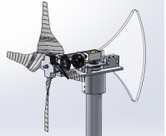
Figure 3.1: NAU CWC ‘17 [1]

The NAU wind turbine that was built to compete in the 2017 Collegiate Wind Competition featured a design that used four-blades, an open nacelle, and an acrylic passive yawing mechanism. The turbine used a four-blade design to achieve a high solidity in the swept area without creating blades with an unusual chord length. The acrylic yaw ultimately did not work for the team on the first day of the competition, so the team revamped the design in the hotel the first night to feature a two-tail wooden yaw to produce the yawing torque necessary to steer the turbine into the wind effectively. The two-tail wooden yaw performed better than the original single-tailed acrylic tail. The team ultimately did well in their competition, and therefore provides a strong design for reference in designing our own turbine.

3.2.2 Existing Design #2: PSU CWC ‘17
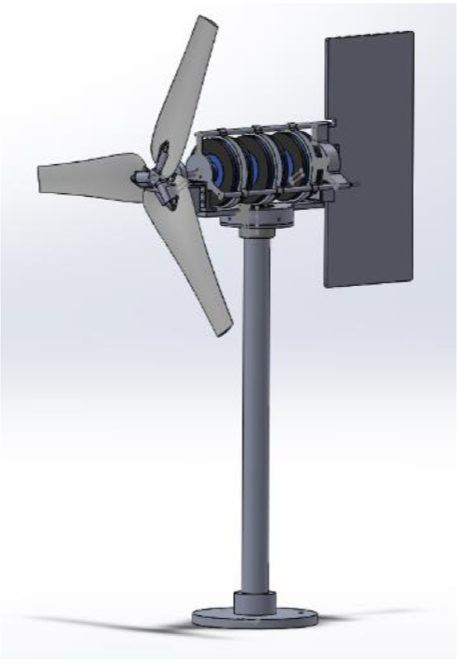
Figure 3.2: PSU CWC ‘17 [2]
The Penn State University (PSU) wind turbine for the 2017 competition implemented a couple different components that NAU turbines have not yet included. Blade design for this turbine was especially eccentric and performed well, earning a first-place overall finish in the 2017 competition. The blades were designed in a way to overcome the high torque requirements in accordance with the generator team’s design. The team achieved this by optimizing the solidity and keeping a blade number of three to find the balance of rpm and torque requirements. In addition, as PSU teams have done frequently, an active pitching mechanism was implemented into their design to avoid aerodynamic hysteresis and accomplish cutting-in at a low wind speed. The pitching mechanism was designed in such a way that the blades could be controlled throughout the testing duration to maintain an optimum angle of attack, and therefore avoid stalling. On the electrical side, an axial flux generator was selected due to its low cogging torque. Additionally, the axial flux generator can produce consistent power at high rpm as well. The combination of these two criteria allowed the turbine to cut-in at low wind speeds and maintain power production at high rpms after reaching the rated wind speed for the turbine. The turbine performed well, earning the top overall design award, winning the competition for 2017. Using this design as a benchmark provides our team knowledge on what top performing designs have looked like in the history of the CWC.

3.2.3 Existing Design #3: NAU CWC ‘18

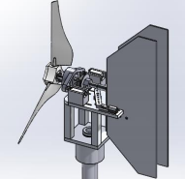
Figure 3.3: NAU CWC ‘18 [3]

The wind turbine that was built to represent NAU’s 2018 Collegiate Wind team implemented a three-bladed, two tail yaw design. The design performed well enough to earn sixth out of twelve teams competing during the most recent wind competition held. The blades were designed to have a long chord length, which causes them to appear thick in Figure 3.3. This chord length was used to achieve a high solidity in a different way than the 2017 NAU team attempted. The design featured a linear actuator with an RC rotary brake set as the braking system. The linear actuator provided enough power to stop the rotor from spinning without much difficulty. While braking the turbine was not an issue, releasing the brakes to allow the turbine to cut-in again was an issue. Many linkages were used as an effort to transfer the translational motion from the actuator to the brake pad. The brake system was inaccurate and difficult to control because of the many unnecessary linkages. Using a linear actuator is a feasible solution to braking if it is done in such a way that the linear actuator is connected to the braked pad mechanism with no more than one linkage. Comparing against this design has allowed our team to iterate upon a high potential turbine. The turbine would have finished in the top 3 if their brake system had not failed.

3.3 Functional Decomposition
Beginning the design process begins with understanding the scenario at hand. In this chapter, the team’s evaluation of each component of the process will be listed. The process of hypothesizing what will happen when our design is tested will lead us to determining a plan to approach the design process with. By formulating a hypothesized decomposition of the testing turbine, our team can devote its resources to the path that we’re hypothesizing. The goal of decomposing the scenario is to ultimately gather information to formulate a focused plan to follow.

3.3.1 Black Box Model
The first step of decomposing the situation that the wind turbine will experience is to express the process in a general form. This general form will create a scope on what enters and exits the system. The details of how the inputs result in the outputs of the system will be addressed in the following section, 3.3.2 Hypothesized Functional Model. In Figure 3.4: Black Box Model, the inputs and outputs of the system are listed. The inputs and outputs of the model are broken into three categories: Material, Energy, and Signal.
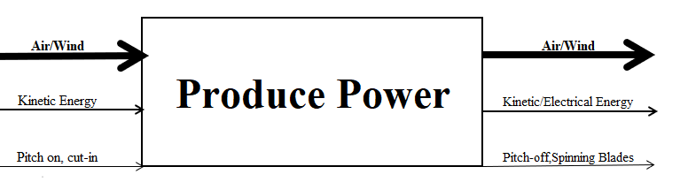
Figure 3.4: Black Box Model

As the input, and output, air is the primary driving concern for the wind turbine. The mass flow rate of the wind will be what causes the turbine to begin moving. The wind turbine will convert kinetic energy from the wind into electrical energy, which can be found on the second, medium-thickness line. The input material has mass which results in power produced. The signal input is more complicated than the inputs for material and energy. To properly operate the wind turbine, the blades must be pitched into the wind so that the rotor can cut-in (begin to spin). The signal output consists of similar outputs. The pitch is turned off to allow the blade to return to its normal operating state, while continuing to spin. The pitch and motion of the blades are considered signals because they are both visual verification that the turbine is operating for an observer. The inputs and outputs will result in the production of electrical power.

3.3.2 Functional Model
The functional model elaborates on the black box model, breaking down the operation of the test turbine, illustrating the process that the turbine will complete to achieve its purpose, producing power. The wind turbine is comprised of a variety of components, interacting with each other through many types of energy, as indicated in Figure 3.5. For the wind turbine to operate, there must be wind blowing, otherwise there is no kinetic energy to convert into electrical energy. The blades are designed in such a way that the wind imparts a lift force on the blades, resulting in rotation of the rotor system. A torque is imparted on the shaft, which rotates the generator. Rotating the generator is the goal of the turbine, so that power can be generated. The turbine must accomplish other tasks, that are listed as side branches from the main line of Figure 3.5: Functional Model. The purpose of the model is for the team to hypothesize each detail involved within the operation of the wind turbine. The goal of creating this model is to gather the importance of each step, and allowing the team
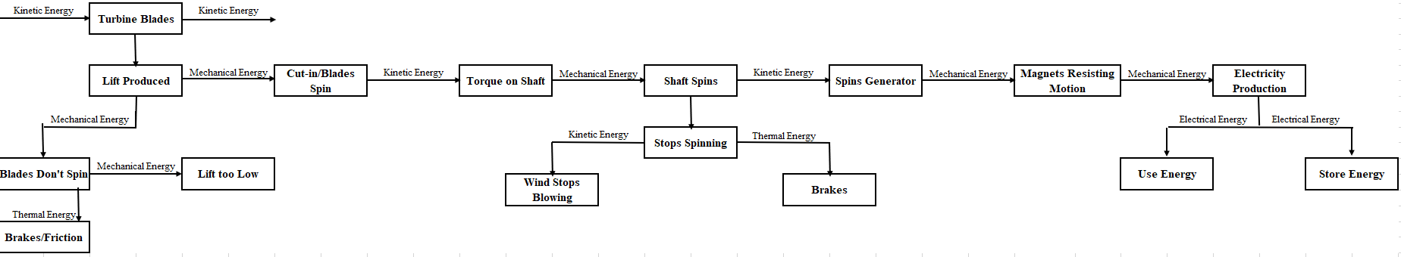 Figure 3.5: Functional Model

3.4 Subsystem Level
The turbine that the team is planning on building will consist of five different subsystems. Each subsystem in the machine will be necessary to operate the turbine. Optimizing the

3.4.1 Subsystem #1: Blade Design
Designing the blades of the turbine will be the most vital component of the design. To create the proper amount of lift to get the blades spinning. Getting the blades spinning requires an in-depth analysis of the incoming flow that the turbine will experience. After converging on a flow solution, it will then be necessary to find the proper combination of airfoils and evaluate the airfoils in Q-Blade.

3.4.1.1 Existing Design #1: Betz Blade
The Betz Blade is a simplified model of blade analysis that only considers the Blade Element Momentum Theory. The flow considered is fully laminar. The model does not consider more complex components for modeling such as turbulence and wake.

3.4.1.2 Existing Design #2: ALTEMP Blade
NAU’s Collegiate Wind Competition Team that competed in the 2017 competition used ALTEMP in creating their blades. This material is can be easily manufactured but does not provide the stiffness that other feasible blade materials will provide. The material is a strong contender because it strikes the balance between cost and functionality.

3.4.1.3 Existing Design #3: Carbon Fiber Blade
Teams representing NAU have used carbon fiber blades in the past. Carbon fiber has properties that would have relevant properties to create the blade. Carbon Fiber is stiff and strong but tends to be more expensive than most other feasible options. Due to advances in technology, 3D printing carbon fiber blades makes the concept of using the material much more financially feasible.

3.4.2 Subsystem #2: Yaw Design
When a wind turbine has an appropriate yaw design, the direction of optimal wind will be achieved thus increasing efficiency of the wind turbine. When wind is at its optimum, the energy generated by the wind turbine is very high and this is mainly achieved when the yaw is focused on an optimal angle to the incoming wind hence making it to rotate in an effective manner thus leading to a high energy production. Three existing yaw designs are as discussed below.

3.4.2.1 Existing Design #1: ABM Greiffenberger Yaw
The new ABM Greiffenberger yaw drives has the ability of maintaining nacelle positions in the wind direction to maximize generation of energy. It has a combination of induction motors and multi-stage planetary gearboxes. The motors have an outputs range of 2.2 to 22 kW. Drive systems have output torque ratings with a range of 2,000 to 50,000 Nm and maximum output torques of up to 100, 000 Nm [4].

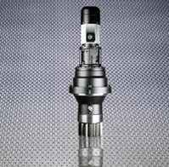
Figure 3.6: ABM Greiffenberger [4]

3.4.2.2 Existing Design #2: Yaw 700 TW
700 TW - Wind Turbine Yaw has output shafts which are supported by heavy duty bearings and has a high transmissible torque. It also has a high radial load capacity, high shock resistance, high efficiency, low weight and a wide range of reduction ratios ranging from 60 up to 3000 [5].

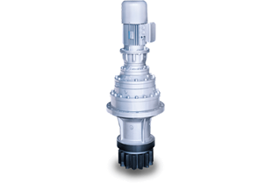
Figure 3.7: 700 TW Yaw [5]

3.4.2.3 Existing Design #3: 700T Yaw
700T series yaw design has the ability of limiting peak of torque hence avoiding instances of failure. It is externally placed in relation to the gear box and hence can be replaced with ease. It has the ability of shutting down the gearbox when torque limit is reached [6].
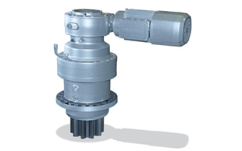
Figure 3.8: 700T Yaw [6]

3.4.3 Subsystem #3: Brake Design
The brake design must slow the wind turbine down to a complete stop at wind speeds up to 20 m/s. The system must be able to brake on command and be able to release the brake when the turbine must start back up.

3.4.3.1 Existing Design #1: Hydraulic Braking System
The first braking system uses hydraulics to activate the brakes. There have been few teams in past Collegiate Wind Competitions to use hydraulic brakes, but there are plenty of RC cars out there that use them, and they typically work well. Hydraulic brakes work by pushing a rod forward into hydraulic fluid which can push the fluid into the opposite end of a cylinder. This design is strong and durable in a wind turbine application, but it is not very cost effective and can be hard to assemble.

3.4.3.2 Existing Design #2: Linear Actuator Braking System
NAU’s 2018 Collegiate Wind Competition team used a linear actuator to activate the brakes. The linear actuator will use Arduino to tell the actuator to push the rod forward to activate the brakes or to bring the rod back to release the brakes. This design is very compact and is strong, but the one downside is the cost.

3.4.3.3 Existing Design #3: Dynamic Braking System
Collegiate Wind Competition teams in the past have used dynamic braking system. This design uses the generator on the wind turbine to create a resistive torque on the system [7]. To create a resistive torque a relay will be used to short the system. For this system to work, a generator with a kV rating between 100-200 would work the best. A kV rating is the amount of revolutions per minute (rpm) per open circuit voltage. Dynamic braking is cost effective because a generator is already needed to capture energy in the system, but a downside to this design is at high wind speeds they are proven to be unreliable.

3.4.4 Subsystem #4: Shaft designs
The shaft is a crucial component of the wind turbine since it is responsible for spinning the generator to produce electricity. Three shaft designs have been described below.

3.4.4.1 Existing Design #1: Wind-Turbine-Shaft (HS-0018)
This shaft is characterized by high strength since it is made up of steel. It has low porosity and long service life. However, it is expensive [7]. It is presented in the figure below.
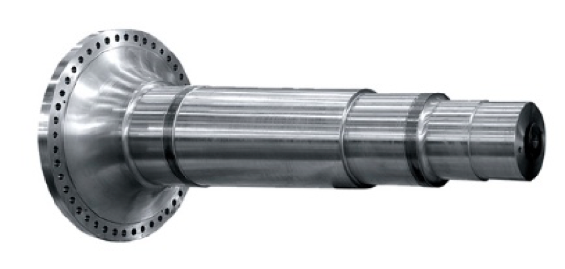
Figure 3.9 Wind-Turbine-Shaft (HS-0018) [8]

3.4.4.2 Existing Design #2: Turbine Generator Shaft Rs 1.25 Lakh
This shaft is characterized by high tensile stress hence it can withstand a lot of pressure and great loads. It is made of steel and can last for a long period of time. However, it is very expensive [8]. It is shown in the diagram below.

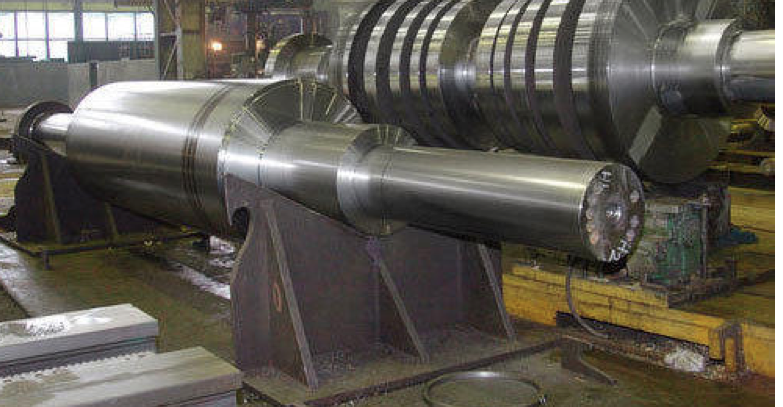
Figure 3.10: Turbine Generator Shaft Rs 1.25 Lakh [8]

3.4.4.3 Existing Design #3: Guoguang rotor shaft
This shaft is characterized by high strength since it is made up of steel. This also facilitates durability of the design. The disadvantage is that it is expensive [8]. It is represented in the diagram below.

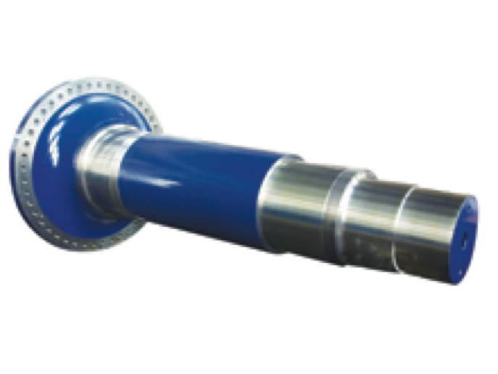
Figure 3.11: Guoguang rotor shaft [9]

3.4.5 Subsystem #5: Tower
The tower of the wind turbine is very crucial since it supports all the other components of the wind turbine. Existing Tower designs are discussed in this section.

3.4.5.1 Existing Design #1: Hybrid Tower
It is comprised of a concrete tower which is mounted directly on the base at the location and then pre-stressed. The advantage of this is that the concrete tube is produced on site, hence reduction on transport cost. The entire system has an adequate resonance frequency as the diameter of the concrete element which is fitted in the lower part of the hybrid tower is adjustable.
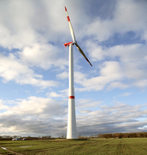
Figure 3.12: Hybrid Tower Design [10]

3.4.5.2 Existing Design #2: Lattice Tower
This design is characterized by a zigzag body made up of steel. The design makes the tower strong thus can withstand strong winds and load. It is appropriate for wind turbines with long and heavy blades. It is shown in the figure below.
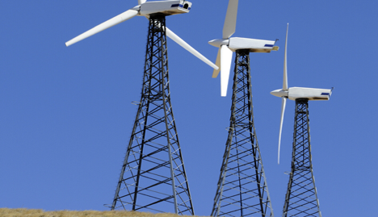
Figure 3.13: Lattice Tower [10]

3.4.5.3 Existing Design #3: Steel tubular tower
This tower design is made up of steel and hence it is strong and highly durable. It has a high level of ductility hence can handle large deformations. Also, it has a high tensile strength and can be easily fabricated [4]. It is as shown in the figure below.

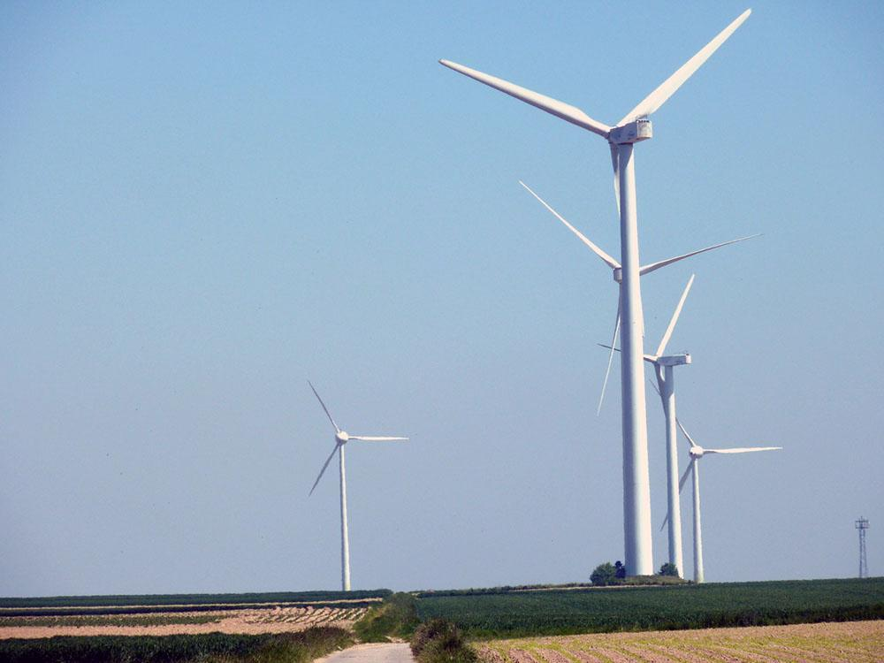
Figure 3.14: Steel Tubular Tower [10]

4 DESIGNS CONSIDERED
In this section concepts for each subsystem have been designed in accordance to customer and engineering requirements. The subsystems include brakes, blades, shaft, yaw, and tower design. Two designs for each subsystem is shown below, and the remaining designs can be found in Appendix B.

4.1 Design #1: Stepper Motor with Lead Screw Brake
In the first design, seen in figure 4.1, a stepper motor is being used to initiate the brakes when the wind turbine is spinning. When the turbine is required to brake, the stepper motor will turn the lead screw that is attached to a nut on the brake caliper which will cause the brake caliper to press against the rotor to stop the turbine. The main advantage of this braking system is that stepper motors are very accurate and can get to the same position repeatedly with very little variance. Another advantage is that stepper motors are cheap if you compare them to a linear actuator. The disadvantage for this system is that stepper motors tend to be bigger than linear actuators, so when designing the nacelle more space will need to be allocated to the design.
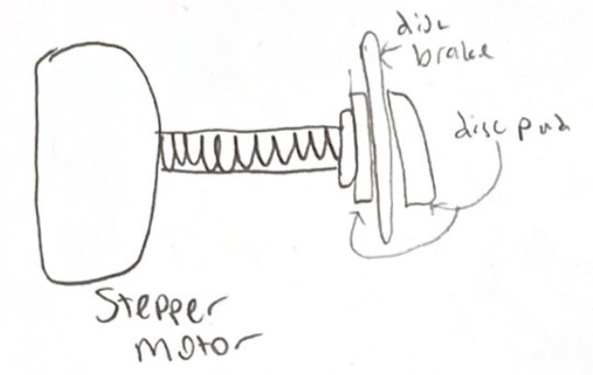
Figure 4.1: Stepper Motor with Lead Screw Brake

4.2 Design #2: Linear Actuator Braking System
The second brake design, shown in Appendix B.1, shows a linear actuator pushing the brake pad into the rotor disc. When braking is required, the linear actuator will be attached to the brake pad and move forward to apply pressure to the rotor disc. The main advantages to this system are that it is lightweight, has a small volume, and can apply an effective of force. A big disadvantage to using a linear actuator is the cost.

4.3 Design #3: Small Blade
The first feasible concept considered for the blade concept generation was the small blade drawing concept. This thought considered a blade which would be much smaller than the maximum 45x45cm² cross-sectional swept area for the wind’s entry to the system. This blade considers a strong factor in the performance of the blade, and that is the overall weight of the blade. The small blade concept would have the advantage of having an early cut-in wind speed due to the lack of material necessary to create blade rotation. The primary disadvantage to this design is that the rotor will not be optimized because the blades will be smaller than the largest possible swept area. The swept area of a turbine is a driving factor in a turbine’s overall effectiveness. The original drawing of this concept can be found below in Figure 4.2: Small Blade Concept.
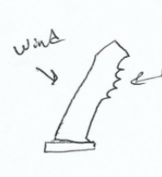
Figure 4.2: Small Blade Concept

4.4 Design #4: Wide Base Blade
The other most feasible blade concept was the wide base blade concept. The wide base concept implemented a blade that would lead to a higher solidity of blades, which is the ratio of blade material vs. empty space in the swept area by the rotor components. The higher solidity of the swept area generally results in a higher torque on the shaft, overcoming the resistive and cogging torques that the shaft will experience during start up. In addition, using a wide base blade will allow the blades to maintain consistent Reynold’s Number operating conditions across the length of the blade. The disadvantages to using this blade concept are that the blade will need more material to make. Due to the extra material to make the blade, the weight will be increased leading to a more difficult time for the turbine to cut-in. Additionally, using more material means the wide base blade will be more expensive to manufacture than the small blade concept listed in the previous section. In Appendix B.2, the original concept drawing for the wide base blade is shown.

4.5 Design #5: Roll Chair Tower Design
The design resembles a rolling chair. Its major advantage is that it is lighter than a baseplate. Its major disadvantage is that it is not stable enough to withstand the wind. It also can move easily if the high wind hit the chair. It also does not meet competition requirements. This figure can be seen in Appendix B.3.

4.6 Design #6: CWC ’18 tower design
The design gets its concept from the NAU ‘18 Collegiate Wind Competition tower design. Its major advantage is that it is stable and can be fastened to mount in the ground. It can resist pressure, tension and strong wind speeds.
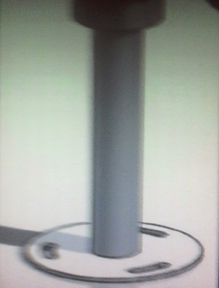
Figure 4.3: CWC ’18 tower design [3]

4.7 Design #7: Yaw Incorporated Tower Design
The design mimics the tower. Its major advantage is that it would perform its purpose of a tower while also contributing to other components (yawing system) of the turbine. The disadvantages are that it has inefficient yawing power and too little surface area. This figure can be seen in Appendix B.4.

4.8 Design #8: Angled Pyramid Scheme Yaw Design
This design resembles a pyramid. Its major advantage is that it is compact, strong and has high efficiency. Its major con is that it is heavier than other potential yaws.

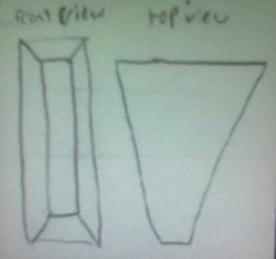
Figure 4.4: Angled Pyramid Yaw

4.9 Design #9: Hollow Shaft Design
The design has a tube which is hollow. Its major pros are a weight reduction concept and is easier to rotate. The major con is that it has a smaller cross-sectional area hence less durable.

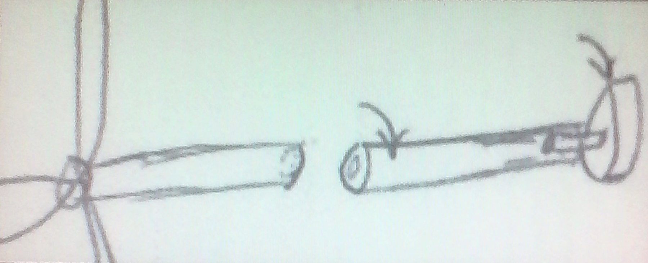
Figure 4.5: Hollow shaft design

4.10 Design #10: Thick Diameter Ends Shaft Design
The design entail ends which are thicker. Its major pro is larger cross-section which facilitates durability at concentrated stress points. Its cons are that it is heavier than necessary and has higher stress concentration at diameter changes. This design can be seen in Appendix B.5.

5 DESIGNS SELECTED – First Semester
Section 5 goes over the processes of selecting the best design for each subsystem. First, each design was put into a Pugh Chart and was narrowed down to the top three choices that were then put into a Decision Matrix. With the raw score for each design, the best design was chosen for each system.

5.1 Rationale for Design Selection
The team compiled potential designs into selection tools created by the team known as Pugh charts and decision matrices. The team used the Pugh charts to determine the most viable option for the designated subsystem. Each subsystem had its own Pugh Chart and Decision Matrix to determine the best concept for development. In Chapter 5.1, the results of the selection phase will be discussed and shown.

5.1.1 Blade Design Selection
A Pugh chart was used to evaluate the optimum blade concept that our team would use. In Table 5.1, the variation of blades that were conceptualized during the concept generation phase can be found. These blades were compared to a datum, which is the Betz Blade model. This datum is a simple blade model that ignores many factors that can impact blade performance but allows the team a simple conceptualization of turbine blades. In the Pugh chart, the team found that the wide bade blade would be the best candidate from our concepts generated, while the small blade concept would be the second most efficient/viable option.

Table 5.1: Blade Pugh Chart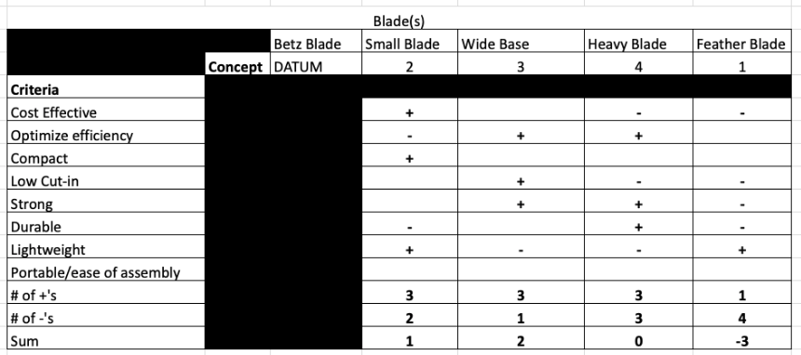

After completing the Pugh Chart for the blade concepts, the team compiled the highest scores into a decision matrix. The decision matrix, shown in Table 5.2, showed our team that the best concept overall would be a wide based blade. Devoting energy to this design will allow our team to optimize the swept area of the blades, while also increasing solidity near the root. This increased solidity will increase the torque that the blade can impart around the shaft.

Table 5.2: Blade Design Decision Matrix
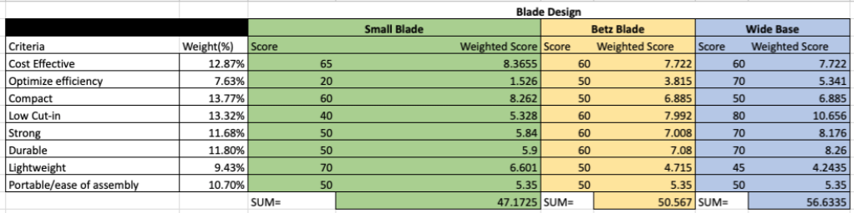

5.1.2 Brake Design Selection
In Table 5.1, the brake concepts were compared against customer requirements for the subsystem. Five concepts were compared against the datum, NAU’s CWC ’18 brake design. The design they used was a linear actuator design with a three-stage lever system to control a brake pad system with a floating rotor.

Table 5.3: Brake Design Pugh Chart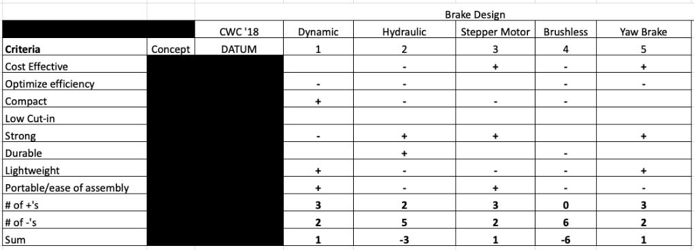

After completing the Pugh chart for brake selection, it was found that dynamic braking, stepper motor actuation, and a yaw brake were the most viable concepts, all rating higher than the datum. These three designs were gathered into a decision matrix (Table 5.2) to determine the best overall brake concept. The Yaw brake concept was not a viable concept in practice, so it was not evaluated in the decision matrix. NAU’s ’18 brake design was then the third concept evaluated within the brake design decision matrix.

Table 5.4: Brake Design Decision Matrix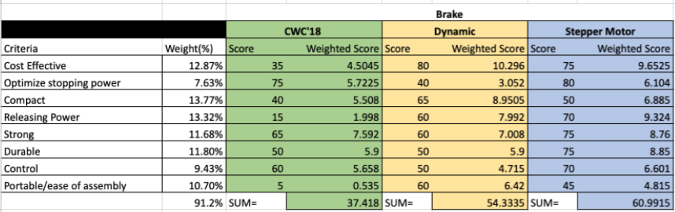
The concept that the team will invest further research and development in will be the stepper motor system. This system will use qualities of other systems, such as the floating rotor with brake pads, to complete its task.

5.1.3 Tower Design Selection
The same process was used again for the tower design subsystem. This subsystem supports the nacelle and its connected parts. In addition, the tower acts as housing for the electrical wires that leave the tunnel during testing. Lastly, the tower is the machine’s only connection to the fastening plate. The tower’s strength is essential to the safety and operation of the wind turbine. The Pugh chart and Decision matrix for the tower selection can be found in Appendix C.1 and C.2. The datum was NAU 2018’s Tower Design, due to its strong performance in last year’s performance and recommendation from our faculty advisor. The design was a simple pipe welded to a baseplate of the same material, which had slots cut out of it to fasten to the competition mount. In the Pugh chart, our team compared our five best concepts against last year’s team. In comparison, each concept in the Pugh chart scored negatively against last year’s design. Regardless, the designs with best scores were rated in a decision matrix, which were the mesh tower, wide base tower, and triangular prism tower. The mesh tower was ruled out when advancing to the decision matrix due to its difficult manufacturing and compromised structural integrity (lack of solidity throughout the length of the tower). Using a decision matrix, it was determined that the wide base tower design and previous year’s design were nearly tied after completing the ratings within the decision matrix. The design that overall won was the wide base design. This design is advantageous because of its lower drag and weight at the top of the tower, reducing the acting moments about the base of tower.

5.1.4 Yaw Design Selection
As part of the competition requirements, the turbine must implement a yawing mechanism. The yawing mechanism will direct the turbine into the wind to maximize the efficiency of the turbine. Our team is focusing on a passive yawing system. The passive yaw concepts that were generated were treated the same as the previous three subsystems. The Pugh chart for the yaw used the 2108 NAU yaw design as the datum, while five generated concepts were compared to it. The concepts that scored the highest in the Pugh Chart phase were the Pyramid (connected tip), Pyramid (separated tip), and Rough surface yaw concepts. Due to the high rating that these concepts scored, the decision matrix for the yaw system was used with the three highly rated concepts, rather than rating the previous year’s yaw design. All three concepts scored nearly identically in the decision matrix. The design that the team will devote attention to is the Pyramid tip design. The yaw selection tools can be found in Appendix C.3 & C.4.

5.1.5 Shaft Design Selection
The shaft in our design must be strong and durable enough to handle a high number of cycles under multiple loading scenarios. Our overall system will contain a hub with connected blades, a swashplate, a braking rotor, a bearing, and a generator. Each of these listed items will be connected to the shaft in a different way, imparting a unique force at several different locations. The 2018 team created a shaft that can withstand these forces, and our concepts were evaluated with the many different factors considered. In the Pugh Chart, the 2018 design was the datum.
Our team had two concepts that were rated better than the other two that were considered in the decision matrix. The two best concepts generated were the polymer shaft and hollow shaft concepts, which both were negatively ranked in the Pugh chart phase, like the Pugh chart for the tower design selection. The shaft decision matrix showed that the most efficient and viable shaft was the 2018 design. Our team will focus on a design like this, with modifications to the shape. Due to its success in last year’s competition, our advisor has expressed that a similar design would be a strong candidate for our design. The selection tools developed for selecting a strong shaft design can be found in Appendix C.5 & C.6.

5.2 Design Description
This section will discuss the process the team used to develop designs for the selected concepts in section 5.1.

5.2.1 Blade Design
The blades are designed to implement multiple airfoils throughout the blade due to the varying operating conditions across the length of the blade. To quantify the several different operating conditions, the Reynold’s number was calculated in two different operating scenarios, start-up and during operation. Before the calculation for Reynold’s number can be calculated, the geometry of the blade must be found. Calculating the geometry of blade involved creating a computer code that implemented the use of many equations from Manwell’s Wind Energy Explained Chapter 3: Aerodynamics. The equations used to create the computer code and define a blade shape can be found below in equations 5.1 – 5.4 [11]. The equations include many variables such as $λ$ (tip-speed ratio), $ϕ$ (angle of relative wind), c (chord length), and $Θ_{T}$ (Twist angle relative to tip of blade).

$$\begin{aligned}λ_{r}=λ\left(\frac{r_{i}}{R}\right)\#(5.1)\end{aligned}$$

$$\begin{aligned}ϕ_{i}=\left(\frac{2}{3}\right)\tan^{-1}\left(\frac{1}{λ_{ri}}\right)\#\left(5.2\right)\end{aligned}$$

$$\begin{aligned}c_{i}=\frac{8πr_{i}}{BC_{l}}\left(1-\cos\left(ϕ_{i}\right)\right)\#\left(5.3\right)\end{aligned}$$

$$\begin{aligned}Θ_{Ti}=Θ_{pi}-Θ_{po}\#\left(5.4\right)\end{aligned}$$

The equations shown above calculate the different variables that are essential to calculating the chord length and twist angle, c & $Θ_{T}$. After developing the geometry, equation 5.5 can be used to evaluate the Reynold’s number operating environment for the blade.
$$\begin{aligned}Re_{L}=\frac{ρUL}{μ}\#\left(5.5\right)\end{aligned}$$

The two essential Reynold’s number states for blade operation were calculated to be 3,433 and 63,396 as the start-up and operating environments, respectively. The NACA 8510 & NACA 9612 were chosen based on the Reynold’s numbers to be implemented into the blade for optimum lift and drag effects.

5.2.2 Brake Design
The design chosen for the first iteration of the brake design includes a linear actuator that presses a brake pad into a brake rotor disc. This system is very compact eliminating unnecessary space on the nacelle, making it lighter. Based on calculations done in the individual analysis, a linear actuator was found to be able to apply more clamping force on the brakes. The clamping force was calculated using equation 5.7.
$$\begin{aligned}CF=π*D^{2}*\frac{P}{4}\#\left(5.6\right)\end{aligned}$$

where D is the diameter of the rotor and P is the operating pressure from the linear actuator. Since that is a major role in stopping the wind turbine that design was chosen. In figure # seen below, is the first iteration of the brake design assembly in SolidWorks.
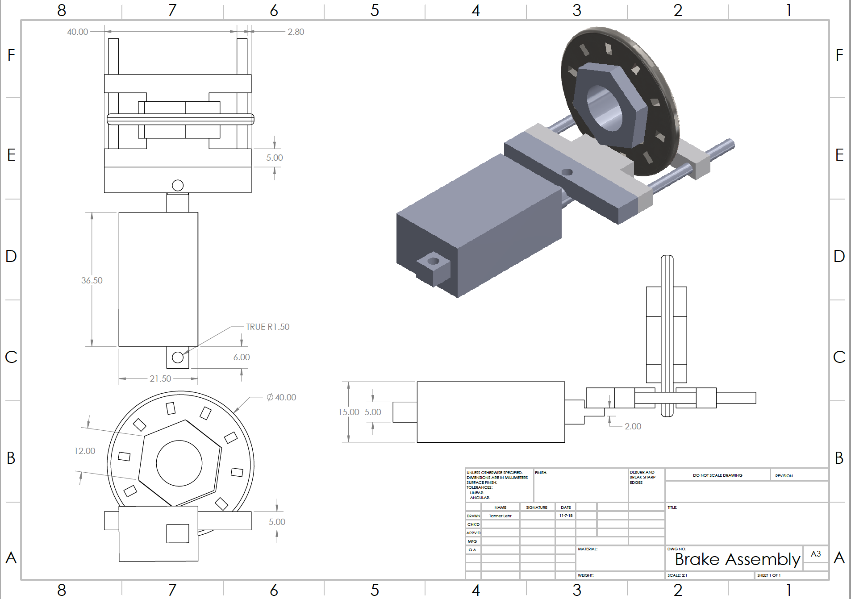
Figure 5.1: Brake Assembly

With the layout of the braking system seen in Figure 5.1, the brakes will be able to activate and deactivate easily without much error. The disc rotor fits onto the shaft hub loosely, which is called a floating brake design. This makes it so when the brake pad being actuated forward can rotate the rotor allowing it to press against the brake pad on the backside of the rotor.

5.2.3 Wide base Tower Design
This tower design is characterized as a cylinder with decreasing cross-sectional area as the tower extends from the base. This tower is stable under even high winds due to the decreasing surface area, leading to a decrease in drag force enacted on the tower. Also, another advantage is that the decreasing cross-sectional area helps to lower the center of gravity of the tower, leading to a more solid stability.

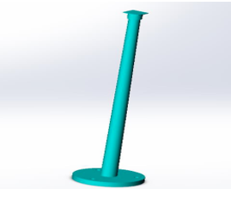

Figure 5.2: Tower Design Image
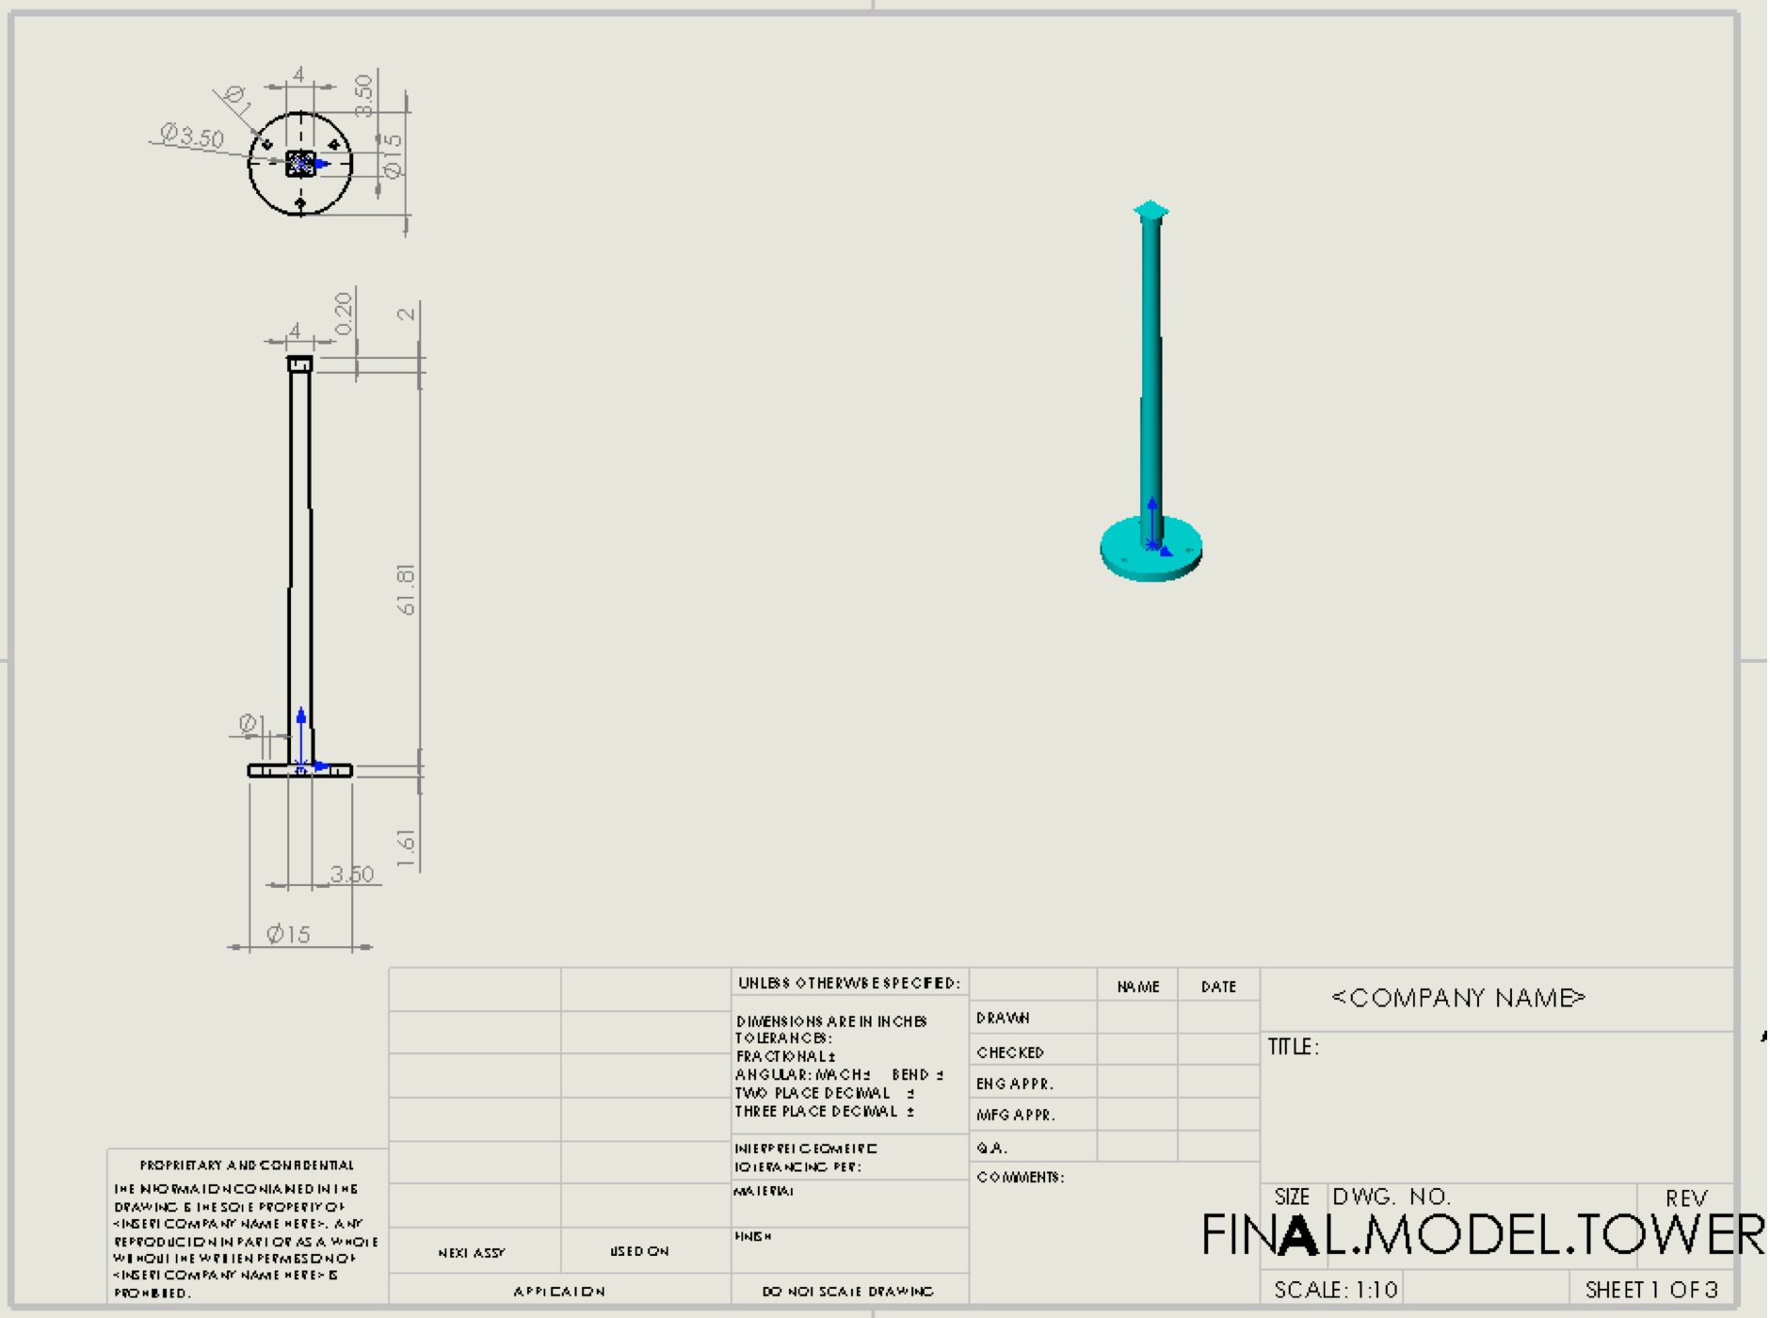
Figure 5.3: CAD Drawing of Tower
Mathematical Modeling
The von mises stress for the plane stress is expressed by use of the following equation [12]:
$$\begin{aligned}σ^{'}=\sqrt{σ_{x}^{2}-σ_{x}σ_{y}+σ_{y}^{2}+3τ_{xy}^{2}}\#\left(5.7\right)\end{aligned}$$

Where $σ_{x}$ and $σ_{y}$ are the normal stresses in the x and y plane respectively, while $τ_{xy}$ is the shear stress in the xy-plane.
The normal strain is calculated using the following equation [12].
$$\begin{aligned}ϵ=\frac{l-l_{0}}{l_{0}} \#\left(5.8\right)\end{aligned}$$

Where $l$ is the original length of the bar and $l_{0}$ is the change in length of the specimen. Furthermore, the factor of safety is defined as the ratio of the yield stress of the material to the allowable stress [12].
$$\begin{aligned}Factor of Safety=\frac{Sy}{σ^{'}}\#\left(5.9\right)\end{aligned}$$

Where, 𝑆𝑦 is the yield stress of the material and 𝜎′ is the calculated Von Mises stress.

After conducting an analysis using the Solidworks simulation it is found out that this tower design can withstand 50 N-m bending force under 20 m/s air velocity without any deformation. The maximum von mises stress is 5.314e+005 Pa and the minimum stress is zero. The maximum displacement is 2.794e-003 mm and the minimum displacement is .01e-030 mm. The maximum value of the strain is 2.331e-006. In addition, of the factor of safety was found to be 3.2e+002.

5.2.4 Angled Yaw Design:
This design is a modified version of yaws that have been successful at the Collegiate Wind Competition in the past as well as successful yaw designs created by NAU’s past teams. The design implements a triangular design to maximize torque around the tower due to the center of gravity being forced away from the axis of rotation as well as increasing the drag force imparted on the surface of the yaw. The wedge design of the yaw is a bit heavier than desired, so future iterations will see a focus on lightening the yaw while maintaining the advantages it currently has.

When the wind turbine operates in yaw, the average amount of power that is extracted an opposed to a situation whereby wind is perpendicular to the rotor plane. Yawing can lead to substantial cyclic gyroscopic loads. These loads are the largest on the blade roots and rotor shaft of small wind turbines and are represented by use of the following equation.
$$\begin{aligned}M=k_{n}Jω\#\left(5.10\right)\end{aligned}$$

Where M is the load(moment), $k_{N}$ is a numerical factor depending on the number of blades, J is the moment of inertia of the blade and $ω$is the yaw rate. This equation gives the maximum magnitude of the cyclic gyroscopic component.

Where P is turbine power, $ρ$ is density, $U_{∞}$ is wind velocity and A is the rotor area. The Solidworks design based on the geometry equations are represented in the diagrams below.

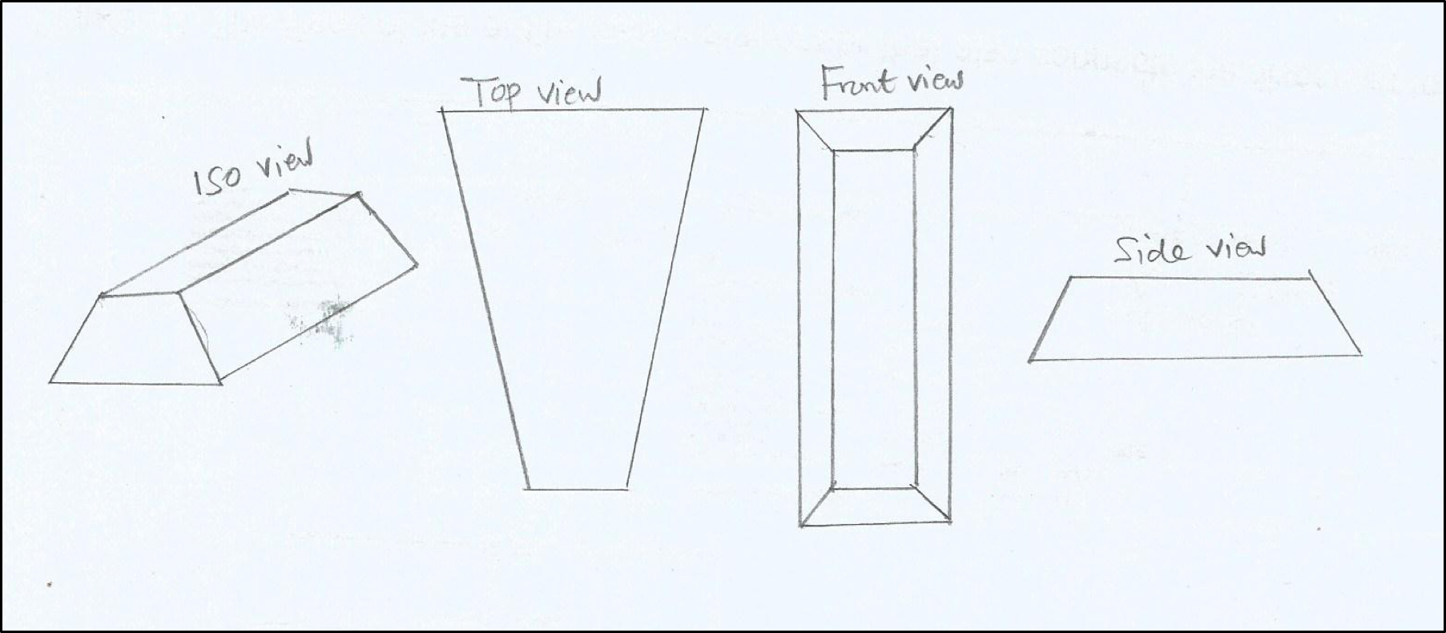
Figure 5.4: Angled pyramid yaw design
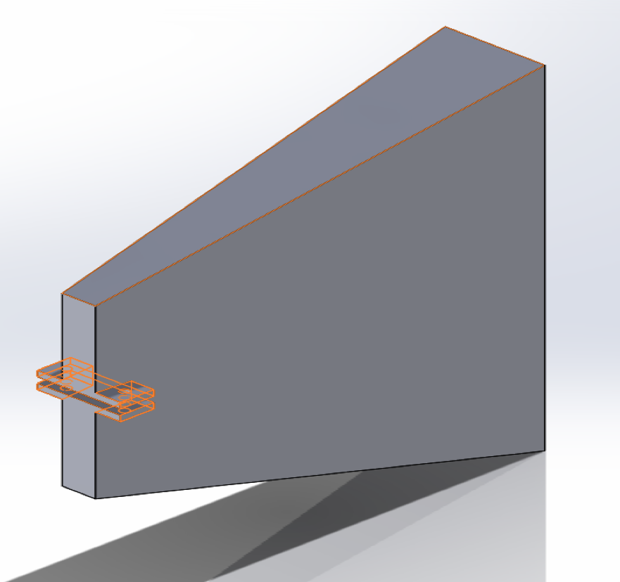
Figure 5.5: Isometric view of yaw
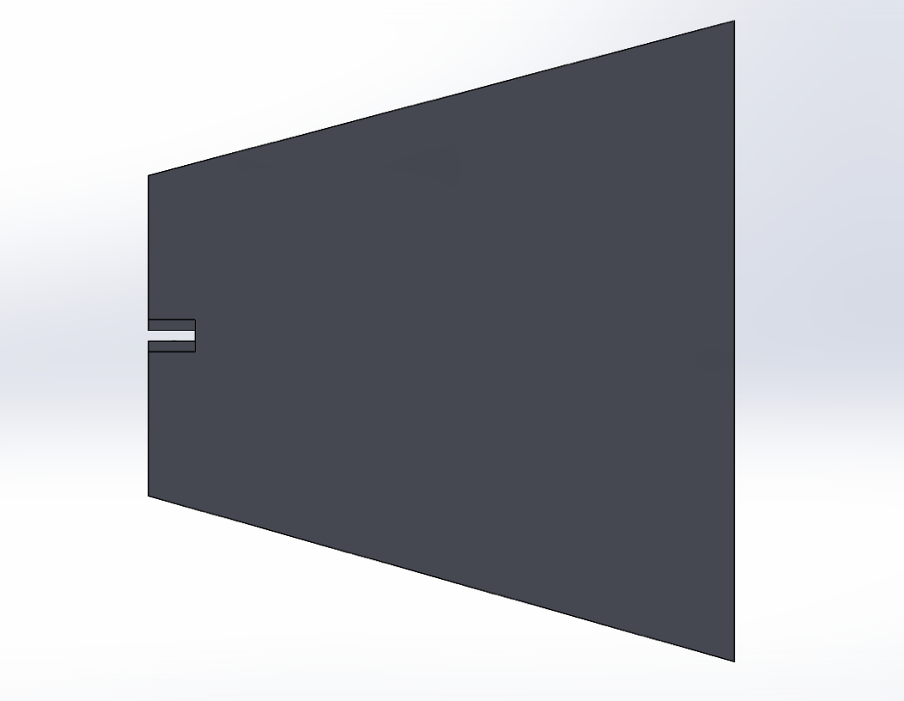
Figure 5.6: Side view of yaw

5.2.5 Hollow Shaft Design:

The hollow shaft design will decrease the weight of the shaft. By decreasing this weight, more mechanical energy can be devoted to spinning the generator. The shaft is ultimately a metallic tube that will be the connecting mechanism between the hub and the generator. This device must be designed to achieve optimum efficiency while maintaining enough strength to withstand the torque enacted on the specimen throughout many cycles.

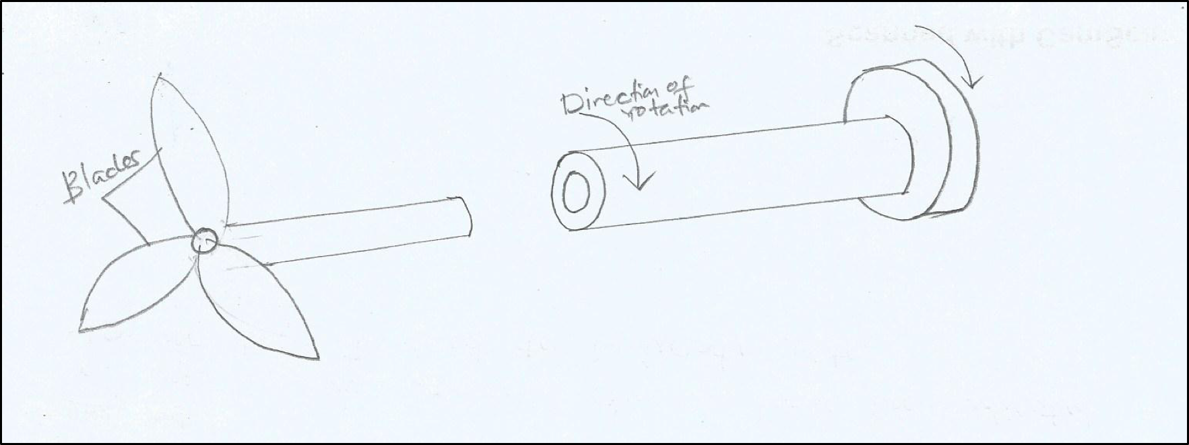
Figure 5.8: Hollow shaft design
Since the shaft will experience several unique loads, materials used to create the shaft should be durable, tough, and strong. To quantify the amount of stress the shaft will experience, many factors need to be considered. Using the equations below (Eq. 5.12 &5.13), using shear and bending moment calculations from the variety of mounted components as the forces, the stress the shaft can withstand can be estimated.

Shafts exposed to twisting moment only are represented using the following equation

$$\begin{aligned}τ_{xy}=\frac{Tr}{J}\#\left(5.12\right)\end{aligned}$$

Where, T is torque (twisting moment), J is the polar moment of inertia of the shaft about the axis of rotation, $τ_{xy}$is the torsional shear stress, and 𝑟 is the radius of the shaft.
Maximum stress applied to the shaft is expressed by use of the following bending equation:

$$\begin{aligned}σ_{x}=\frac{My}{I}\#\left(5.13\right)\end{aligned}$$

Where, M is the bending moment, I is he moment of Inertia about the axis of rotation of the shaft’s cross-sectional area, $σ_{x}$ is the bending stress, and y is the distance from the center of the shaft.

6 Proposed Design
This section describes the full proposed design with all components attached. After choosing the best designs shown in section 5.2, the wind turbine could then be fully assembled. All the individual parts were designed separately in individual analyses and were then adjusted slightly to assemble the full turbine assembly. The first thing that needed to be changed was the length of shaft, this was due to the distance from the generator to the blades was further than anticipated. The next modification to the original design was the yaw, because the length from the nacelle needed to be decreased in order to fit within the volume restraint given by the project sponsor. To make up for the loss of length in the distance off the back of the turbine, the yaw was expanded in the vertical distance and the angle between the intercept of the two sides of the yaw design. The team was able to create a finished proposed design, shown in Figure 6.1.

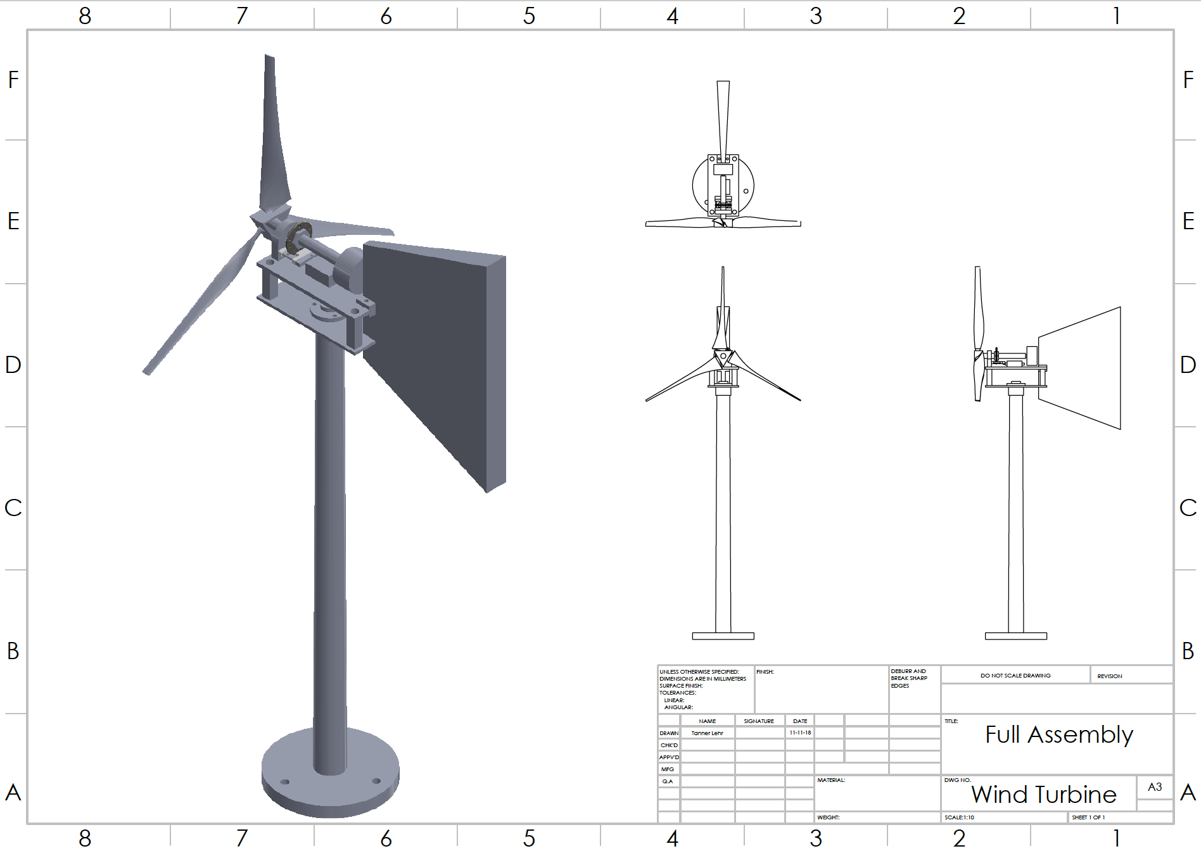
Figure 6.1: Wind Turbine Final Proposed Design
Based on the Final Proposal for the Wind Turbine a Bill of materials was created to show what parts would be needed and how much they cost. With all parts accounted for the total estimated cost to purchase all the necessary parts came out to be $467.48, which can be seen in Table 6.1. As the project progresses, some parts may be added onto this list as well as taken off the list. The budget anticipated is below our budget target.
Table 6.1: Bill of Materials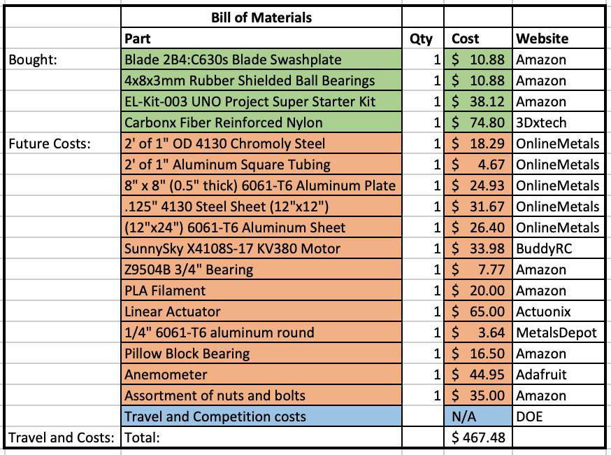

10 REFERENCES

[1] | Northern Arizona University, "Wind Turbine Technical Report," U.S. Department of Energy, Flagstaff, 2017.
[2] | Pennsylvania State University, "2017 Department of Energy Collegiate Wind Competition," US Department of Energy, 2017.
[3] | Northern Arizona University, "NAU Collegiate Wind Competition 2017-2018," U.S. Department of Energy, Flagstaff, 2018.
[4] | ABM Greiffenberger, "ABM Greiffenberger Antriebstechnik GmbH," 2018. [Online]. Available: http://www.abm-antriebe.de/2413_abm_greiffenberger_introduces_new_drive_solutions_for_wind_turbines.html. [Accessed 20 October 2018].
[5] | Bonfiglioli, "700 TW-Wind Turbine Yaw Control gear motor," Bonfiglioli, 2018. [Online]. Available: https://www.bonfiglioli.com.au/en-au/wind/products/gearmotor-gearboxes-for-wind-turbines/product/700tw-wind-turbine-yaw-control-gear-motor. [Accessed 20 October 2018].
[6] | Bonfiglioli, "700T series-Wind Turbine gear motors," Bonfiglioli, 2018. [Online]. Available: https://www.bonfiglioli.com.au/en-au/wind/products/gearmotor-gearboxes-for-wind-turbines/product/700t-series-wind. [Accessed 20 October 2018].
[7] | J. D. a. W. Giewont, "Dynamic Brake Control". United States of America Patent 4761600, 2 August 1988.
[8] | "Wind-Turbine-Shaft (HS-0018)," Made-in-China, 2018. [Online]. Available: https://hshengmic1015.en.made-in-china.com/product/FKCEHRzOZxVY/China-Wind-Turbine-Shaft-HS-0018-.html. [Accessed 19 October 2018].
[9] | "Wind Turbine Rotor Shaft-Guoguang," Calendering machine, 2018. [Online]. Available: http://calenderingmachine.com/4-2-wind-power-turbine-shaft.html. . [Accessed 19 October 2018].
[10] | "Turbines installed on 120 meter high hybrid towers," 2013. [Online]. Available: http://www.nordex-online.com/en/products-services/hybrid-towers.html.
[11] | J. Manwell, Wind Energy Explained, West Sussex, United Kingdom: John Wiley & Sons Ltd., 2002.
[12] | R. G. Budynas and J. K. Nisbett, Shigley's Mechanical Engineering Design 10th edition, New York, New York, USA: McGraw-Hill Education, 2015.
[13] | C. Levandowski, "Lib.dr.iastate.edu," 2018. [Online]. Available: https://lib.dr.iastate.edu/cgi/viewcontent.cgi?article=1116&context=undergradresearch_symposium. [Accessed 20 October 2018].
[14] | D. A. a. J. Veigh, Wind Turbine Materials and Manufacturing Fact Sheet, Princeton: Princeton Energy Resources International, 2001.
[15] | J. S. Strong, "Design of a Small Wind Turbine," 2008.

11 APPENDICES

11.1 Appendix A: House of Quality
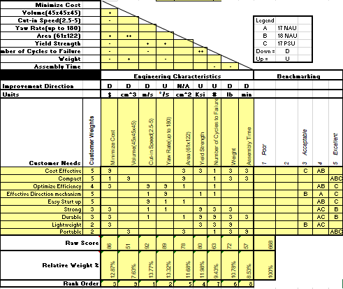

11.2 Appendix B: Designs Considered
Appendix A.1: Linear Actuator Brake
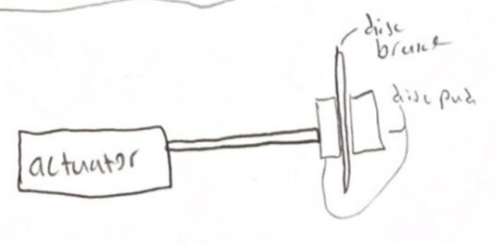

Appendix B.2: Wide Base Blade Concept
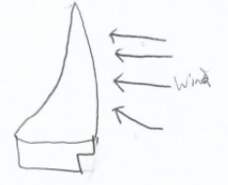

Appendix B.3: Rolly Chair tower design
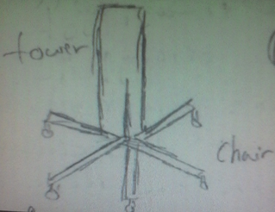

Appendix B.4: Yaw Incorporated Tower
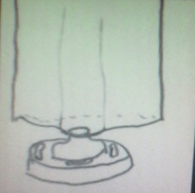

Appendix B.5: Thick Diameter End Shaft
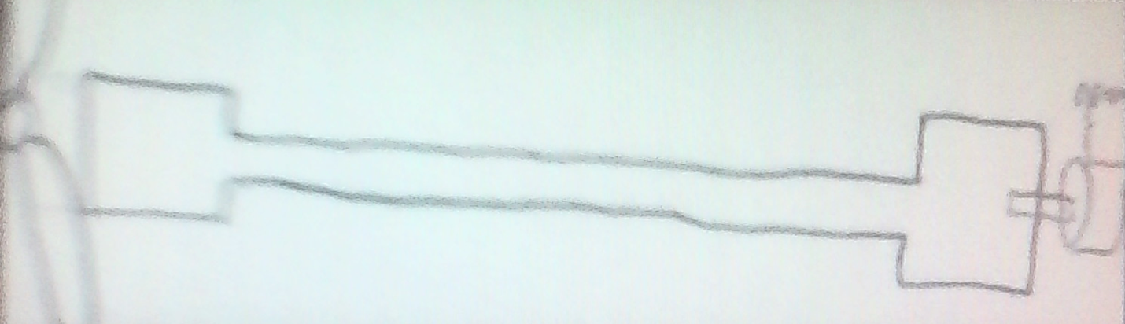

11.3 Appendix C: Designs Selected

Appendix C.1: Tower Pugh Chart
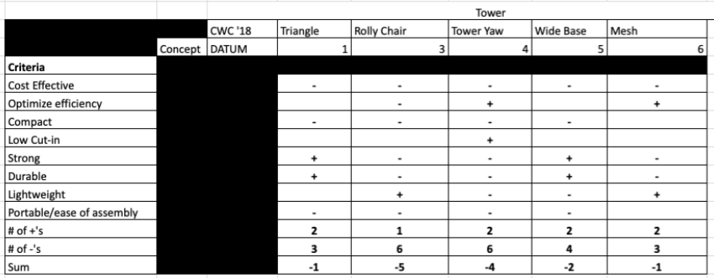

Appendix C.2: Tower Decision Matrix
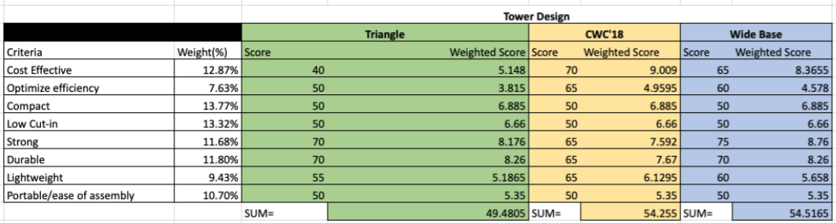

Appendix C.3: Yaw Pugh Chart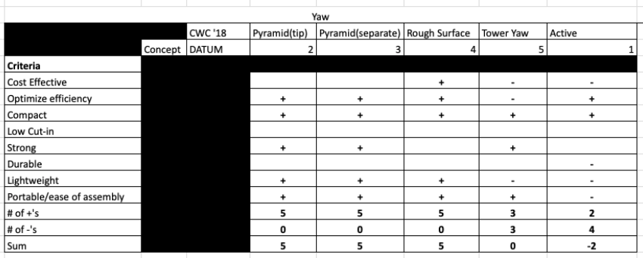

Appendix C.4: Yaw Decision Matrix

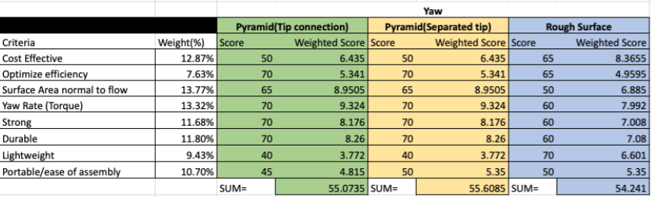

Appendix C.5: Shaft Pugh Chart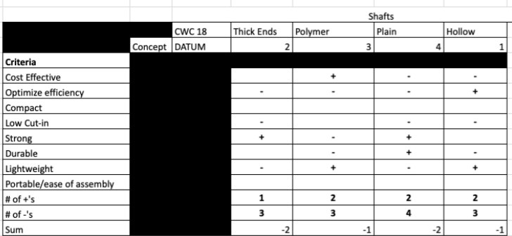

Appendix C.6: Shaft Decision Matrix

